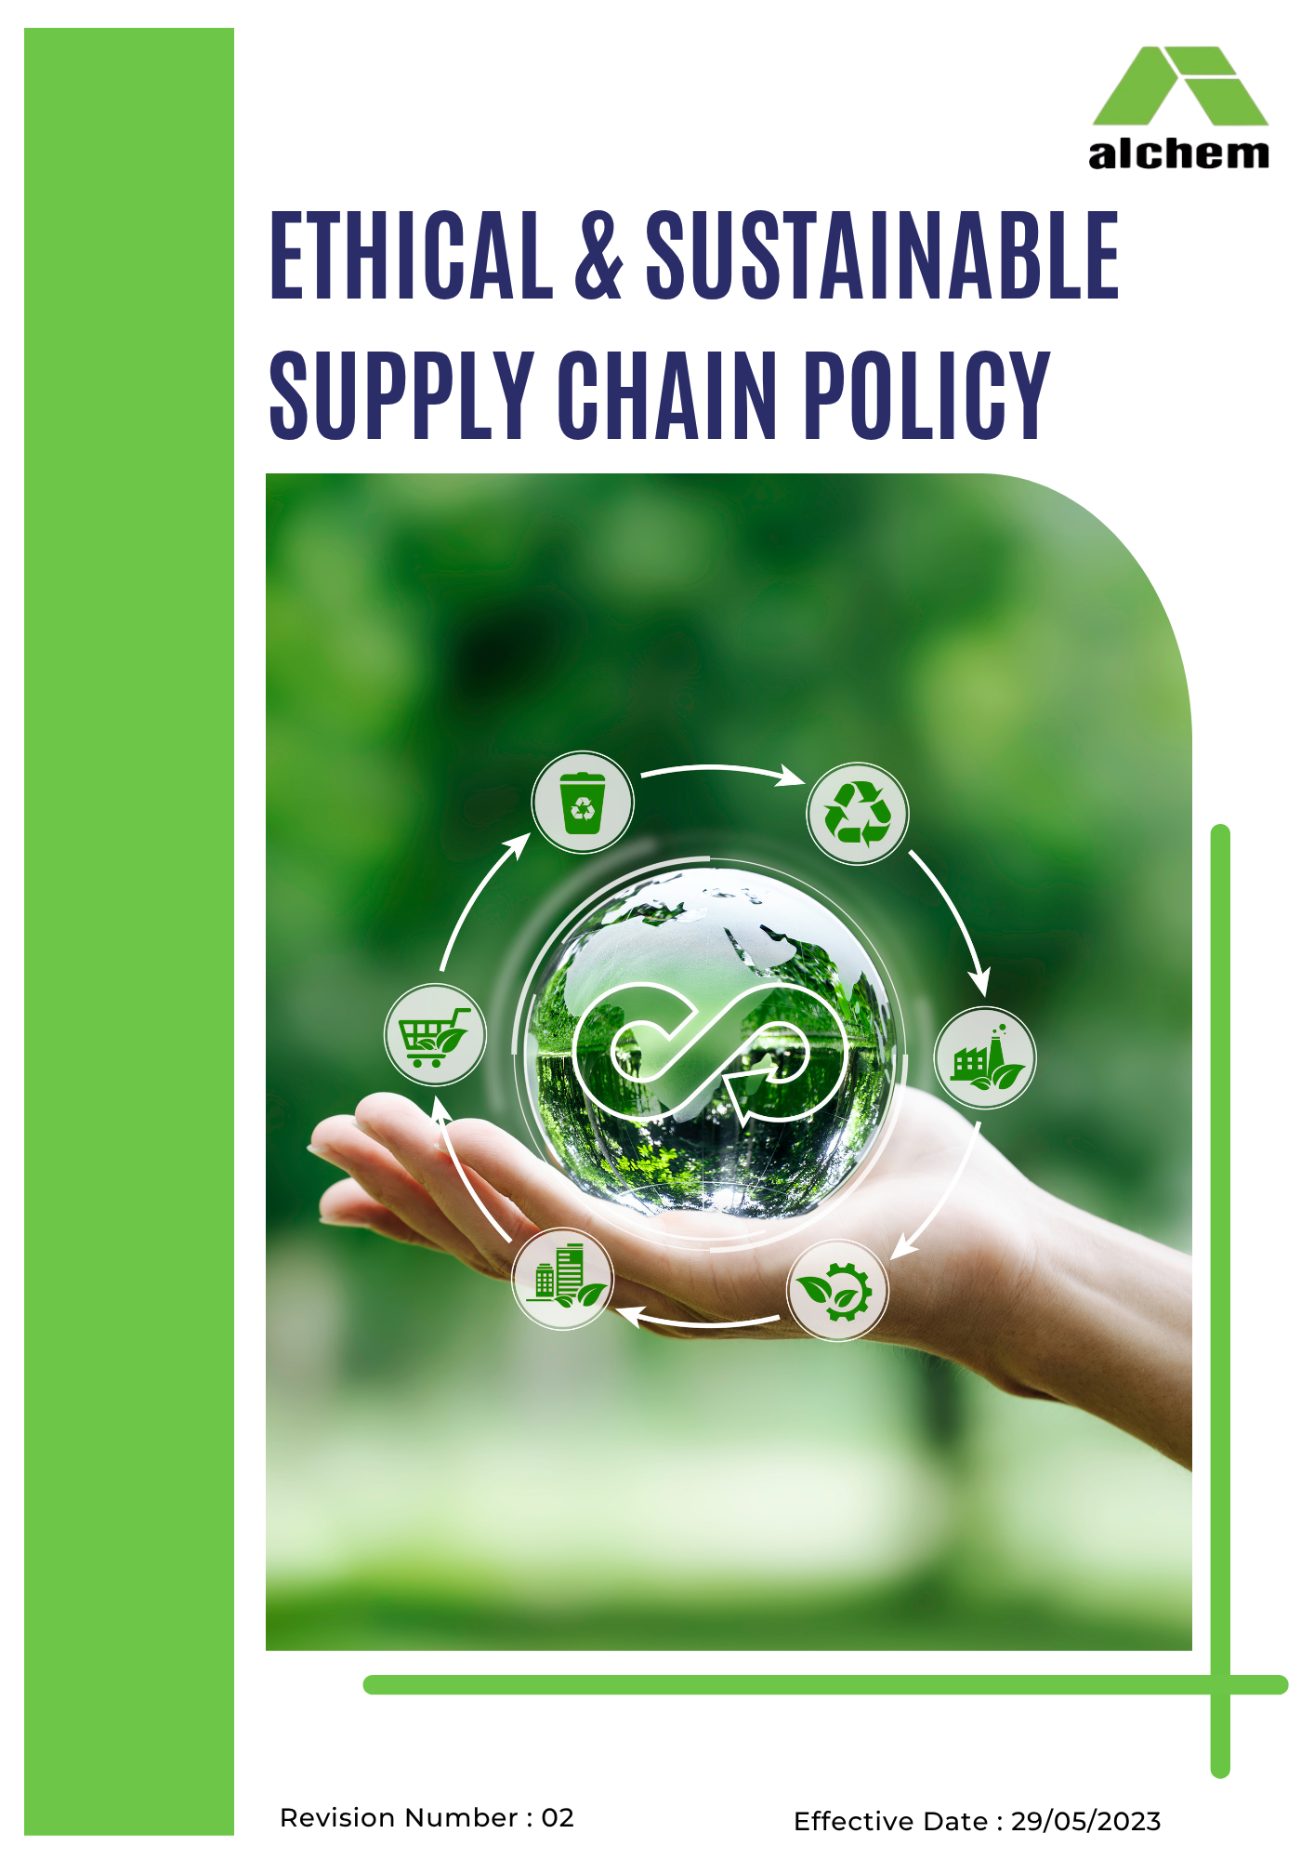
Contents
1. Introduction 3
2. Scope 3
3. Core Principles 3
4. Sustainable Procurement & Responsible Sourcing Commitments 5
5.General Sustainable Procurement Targets 8
6. Action Framework 9
7. Roles and Responsibilities 10
7. Alignment with Sustainable Development Goals (SDGs) 13
8. Policy Review 13
9.Employee Acknowledgement 15

1. Introduction
At Alchem International Pvt. Ltd., we recognize that procurement decisions play a critical role in shaping our environmental, social, ethical, and economic impacts. As a responsible organization, we are committed to integrating sustainability principles into our procurement practices and supply chain management processes.
We believe that sustainable procurement extends beyond cost, quality, and delivery considerations. It encompasses responsible sourcing, ethical business conduct, environmental stewardship, human rights protection, supplier diversity, climate action, and long-term value creation for stakeholders.
Through this Sustainable Procurement & Responsible Sourcing Policy, Alchem seeks to promote responsible business practices throughout its value chain by engaging suppliers, contractors, service providers, and business partners who share our commitment to sustainability, integrity, transparency, and continuous improvement.
This policy establishes the principles, commitments, objectives, and governance framework that guide procurement-related decisions and supplier relationships across Alchem's operations.

2. Scope
This policy applies to:
- All employees, workers, contractors, subcontractors, suppliers, consultants, and business partners operating at or for BALLABGARH SITE
- All activities including manufacturing, warehousing, logistics, administration, product design, research & development, and procurement.
- The surrounding communities and ecosystems that may be affected by our operations.
Location:
Site | Address
BALLABGARH SITE | 201, Empire Plaza, Mehrauli Gurgaon Road Sultanpur 110030 New Delhi, Delhi, India

Baseline Year: FY 2023-24
Target Year: FY 2030-31

3. Core Principles
Alchem’s approach to labour and human rights management is guided by the following principles:
- Responsible Business Conduct
We conduct procurement activities ethically, transparently, and fairly while promoting integrity throughout our supply chain.

- Environmental Stewardship
We encourage suppliers to minimize environmental impacts through responsible resource management, pollution prevention, waste reduction, climate action, and biodiversity protection.
- Respect for Human Rights
We promote the protection of human rights and expect suppliers to maintain fair labor practices, safe working conditions, and respect for worker dignity.
- Sustainable Value Creation
We consider environmental, social, ethical, quality, innovation, resilience, and life-cycle impacts when making procurement decisions.
- Supplier Collaboration
We seek to build long-term partnerships with suppliers that support continuous improvement and sustainable business growth.
- Transparency & Accountability
We encourage openness, accurate reporting, and responsible disclosure of sustainability-related information throughout the supply chain.
- Risk-Based Approach
We proactively identify, assess, and manage environmental, social, ethical, operational, and regulatory risks within our supply chain.

4. Sustainable Procurement & Responsible Sourcing Commitments
For each Social aspect, we set both qualitative objectives (strategic direction) and quantitative targets (measurable outcomes).
4.1 Sustainable Supplier Selection & Evaluation
Qualitative Objectives
- Integrate sustainability considerations into supplier qualification, selection, and performance evaluation processes.
- Assess suppliers based on environmental, social, ethical, quality, operational, and governance criteria.
- Promote transparency and accountability in supplier selection decisions.
- Encourage suppliers to establish sustainability management systems and performance improvement programs.
- Prioritize suppliers demonstrating strong ESG performance and responsible business practices.
Quantitative Targets
- Conduct sustainability assessments for 100% of strategic suppliers by FY 2030-31.
- Include sustainability criteria in 100% of new supplier evaluations.
- Review supplier sustainability performance annually.
- Assess 100% of high-risk suppliers using ESG risk evaluation criteria.
- Increase the proportion of procurement spend covered by sustainability assessments to 90% by FY 2030-31.

4.2 Environmental Sustainability in the Supply Chain
Qualitative Objectives
- Encourage suppliers to reduce greenhouse gas emissions, waste generation, pollution, and resource consumption.
- Promote responsible use of energy, water, raw materials, and natural resources.
- Support suppliers in implementing environmental management systems and climate-related initiatives.
- Encourage adoption of renewable energy, circular economy practices, and environmentally preferable materials.
- Minimize environmental impacts across the product life cycle.

Quantitative Targets
- Assess environmental performance of 100% of strategic suppliers by FY 2030-31.
- Increase procurement spend on environmentally preferable products and services by 20% by FY 2030-31.
- Engage suppliers representing at least 80% of procurement spend on environmental improvement initiatives.
- Increase supplier participation in environmental sustainability programs by 25%.
- Monitor procurement-related Scope 3 emissions annually.

4.3 Human Rights & Labor Standards in the Supply Chain
Qualitative Objectives
- Promote respect for internationally recognized human rights throughout the supply chain.
- Prohibit child labor, forced labor, bonded labor, modern slavery, and human trafficking.
- Encourage fair wages, reasonable working hours, freedom of association, and safe working conditions.
- Support diversity, inclusion, and equal opportunity within supplier operations.
- Encourage suppliers to establish grievance mechanisms and worker engagement processes.
Quantitative Targets
- Assess 100% of high-risk suppliers against labor and human rights criteria.
- Obtain Supplier Code of Conduct acknowledgement from 100% of strategic suppliers.
- Conduct labor and human rights due diligence reviews for 100% of identified high-risk suppliers.
- Maintain zero tolerance for confirmed child labor or forced labor incidents within approved suppliers.
- Review supplier labor performance annually.

4.4 Ethical Sourcing & Business Integrity
Qualitative Objectives
- Promote ethical conduct, integrity, transparency, and accountability throughout procurement activities.
- Prevent bribery, corruption, fraud, conflicts of interest, money laundering, and unethical business practices.
- Encourage suppliers to maintain effective ethics and compliance programs.
- Ensure procurement decisions are made objectively and free from improper influence.
- Promote fair competition and responsible business conduct throughout the value chain.
Quantitative Targets
- Assess 100% of strategic suppliers against ethics and compliance requirements.
- Include ethics and anti-corruption clauses in 100% of new supplier contracts.
- Train 100% of procurement personnel on ethical sourcing requirements.
- Investigate 100% of reported supplier ethics concerns.
- Maintain zero confirmed procurement-related corruption incidents.
4.5 Climate Action & Carbon Management
Qualitative Objectives
- Encourage suppliers to actively measure, manage, and reduce greenhouse gas emissions associated with their operations, products, and services.
- Support the transition toward low-carbon and climate-resilient supply chains.
- Promote energy efficiency, renewable energy adoption, and climate-related risk management among suppliers.
- Integrate climate considerations into procurement decision-making processes.
- Collaborate with suppliers to identify opportunities for reducing supply chain carbon emissions.
Quantitative Targets
- Engage suppliers representing at least 80% of procurement spend on climate action initiatives by FY 2030-31.
- Encourage key suppliers to establish greenhouse gas reduction targets by FY 2030-31.
- Assess climate-related risks for 100% of strategic suppliers annually.
- Monitor procurement-related Scope 3 emissions annually.
- Increase supplier participation in climate and carbon reduction initiatives by 20% by FY 2030-31.
4.6 Circular Economy & Resource Efficiency
Qualitative Objectives
- Promote the efficient use of resources throughout the supply chain.
- Encourage suppliers to minimize waste generation and maximize reuse, recycling, and recovery opportunities.
- Support circular economy principles in product design, packaging, material sourcing, and manufacturing processes.
- Reduce dependency on virgin materials through responsible sourcing alternatives.
- Encourage sustainable packaging solutions and waste reduction initiatives.
Quantitative Targets
- Increase procurement of recycled, recyclable, or renewable materials by 20% by FY 2030-31.
- Achieve 90% recyclable, reusable, or recoverable packaging from strategic suppliers by FY 2030-31.
- Assess resource efficiency performance of strategic suppliers annually.
- Increase supplier participation in circular economy initiatives by 25% by FY 2030-31.
- Encourage suppliers representing at least 75% of procurement spend to implement waste reduction programs.

5.General Sustainable Procurement Targets
Supplier Sustainability
- Conduct sustainability assessments for 100% of strategic suppliers by FY 2030-31.
- Assess 100% of high-risk suppliers using ESG risk evaluation criteria annually.
- Ensure sustainability criteria are incorporated into 100% of new supplier qualification processes.
- Review supplier sustainability performance annually.
Environmental Performance
- Engage suppliers representing at least 80% of procurement spend on environmental improvement initiatives.
- Increase procurement spend on environmentally preferable products and services by 20% by FY 2030-31.
- Monitor procurement-related Scope 3 emissions annually.
- Increase supplier participation in environmental sustainability initiatives by 25% by FY 2030-31.
Human Rights & Labor Standards
- Obtain Supplier Code of Conduct acknowledgement from 100% of strategic suppliers.
- Assess 100% of high-risk suppliers against labor and human rights criteria annually.
- Maintain zero confirmed child labor or forced labor incidents within approved suppliers.
- Complete labor and human rights due diligence reviews for 100% of identified high-risk suppliers.
Ethical Business Conduct
- Assess 100% of strategic suppliers against ethics and compliance requirements.
- Include anti-bribery, anti-corruption, and business integrity clauses in 100% of new supplier contracts.
- Train 100% of procurement personnel on ethical sourcing requirements.
- Investigate 100% of reported supplier ethics concerns.
Climate & Carbon Management
- Engage suppliers responsible for at least 80% of procurement spend on carbon reduction initiatives.
- Encourage key suppliers to establish greenhouse gas reduction targets by FY 2030-31.
- Increase supplier participation in climate-related programs by 20% by FY 2030-31.
Circular Economy & Resource Efficiency
- Increase procurement of recycled or recyclable materials by 20% by FY 2030-31.
- Achieve 90% recyclable, reusable, or recoverable packaging from strategic suppliers by FY 2030-31.
- Encourage suppliers to implement waste reduction and resource efficiency initiatives.

6. Action Framework
To effectively implement this Sustainable Procurement & Responsible Sourcing Policy, Alchem shall establish a structured and risk-based procurement management framework that integrates sustainability considerations into supplier selection, procurement decisions, supplier performance evaluation, and ongoing supplier engagement activities.
Topic | Key Actions
Sustainable Supplier Selection & Evaluation | Integrate ESG criteria into supplier onboarding; conduct supplier pre-qualification assessments; evaluate supplier sustainability performance; maintain approved supplier lists; periodically review supplier performance.
Environmental Sustainability | Assess supplier environmental performance; encourage ISO 14001 certification; monitor environmental risks; promote renewable energy adoption, waste reduction, resource efficiency, and pollution prevention initiatives.
Human Rights & Labor Standards | Conduct labor and human rights assessments; verify compliance with labor laws; review supplier labor practices; monitor high-risk suppliers; implement corrective actions where necessary.
Ethical Sourcing & Business Integrity | Conduct supplier integrity due diligence; communicate anti-corruption expectations; monitor ethics compliance; investigate reported concerns; promote transparency and accountability.
Climate Action & Carbon Management | Engage suppliers on carbon reduction initiatives; encourage GHG emissions reporting; assess climate-related risks; support energy efficiency and renewable energy programs.
Circular Economy & Resource Efficiency | Promote sustainable materials sourcing; encourage recyclable and reusable packaging; support waste reduction initiatives; collaborate on circular economy projects.
Supplier Diversity & Local Procurement | Identify opportunities for local sourcing; support SMEs and local suppliers; encourage supplier diversity; promote inclusive procurement practices.
Responsible Raw Materials & Traceability | Conduct traceability reviews; assess sourcing risks; strengthen transparency within supply chains; maintain responsible sourcing documentation.
Supplier ESG Risk Management | Perform supplier risk assessments; maintain supplier risk registers; monitor corrective action plans; review supplier sustainability performance regularly.
Supplier Development & Capacity Building | Conduct supplier workshops, training sessions, awareness programs, and sustainability engagement activities; share best practices and support performance improvement.

7. Roles and Responsibilities
Board of Directors / Executive Management
Responsibilities:
- Approve and periodically review the Sustainable Procurement & Responsible Sourcing Policy.
- Provide strategic direction and oversight for sustainable procurement initiatives.
- Ensure adequate resources are available for policy implementation.
- Review procurement-related sustainability risks and performance indicators.
- Promote responsible supply chain management throughout the organization.

Chief Procurement Officer (CPO) / Procurement Head
Responsibilities:
- Lead implementation of sustainable procurement initiatives.
- Integrate sustainability considerations into procurement strategies and supplier management processes.
- Monitor achievement of procurement sustainability objectives and targets.
- Ensure procurement activities align with organizational sustainability commitments.
- Report procurement sustainability performance to senior management.
Sustainability & Compliance Team
Responsibilities:
- Support development and implementation of sustainable procurement programs.
- Conduct supplier sustainability assessments and ESG risk evaluations.
- Monitor supplier compliance with sustainability requirements.
- Coordinate supplier audits, assessments, and corrective action programs.
- Track procurement-related sustainability performance indicators.
Procurement Managers & Buyers
Responsibilities:
- Apply sustainability criteria during supplier selection and procurement decisions.
- Engage suppliers regarding sustainability expectations and improvement opportunities.
- Monitor supplier performance and compliance with procurement requirements.
- Support supplier development and capacity-building initiatives.
- Escalate sustainability risks and concerns when identified.
Environment, Health & Safety (EHS) Team
Responsibilities:
- Provide expertise on environmental, health, safety, and sustainability matters.
- Support supplier environmental and occupational health and safety assessments.
- Review supplier environmental performance where applicable.
- Assist with climate, waste, resource efficiency, and environmental risk evaluations.
Quality Assurance Team
Responsibilities:
- Ensure suppliers meet quality, regulatory, and compliance requirements.
- Participate in supplier qualification and performance reviews.
- Support supplier audits and corrective action management.
- Monitor supplier quality-related risks.
Suppliers, Contractors & Business Partners
Responsibilities:
- Comply with Alchem's Supplier Code of Conduct and sustainability requirements.
- Maintain ethical business practices and responsible labor standards.
- Cooperate with assessments, audits, reviews, and corrective action programs.
- Provide accurate and transparent sustainability-related information.
- Continuously improve sustainability performance.

7. Alignment with Sustainable Development Goals (SDGs)
This policy directly contributes to the following UN SDGs:





8. Policy Review
This Ethical & Sustainable Supply chain Policy shall be reviewed annually to ensure its continued relevance, effectiveness, and alignment with Alchem's sustainability objectives, regulatory requirements, stakeholder expectations, industry best practices, and emerging supply chain risks.
The review process shall evaluate:
- Progress against sustainable procurement objectives and quantitative targets.

- Supplier sustainability performance and ESG risk assessments.

- Findings from supplier audits, assessments, and compliance reviews.

- Corrective actions and supplier improvement initiatives.

- Changes in applicable laws, regulations, customer requirements, and sustainability standards.

- Emerging environmental, social, ethical, governance, and supply chain risks.

- Feedback received from employees, suppliers, customers, auditors, and other stakeholders.

- Opportunities to strengthen responsible sourcing practices and supply chain resilience.
- Last Review Date: 06-04-2026
- Next Review Date: 06-04-2027

Approved By:
Designation:

Signature:

Date:

9.Employee Acknowledgement
I acknowledge that I have received, read, and understood the Alchem International Pvt. Ltd. Ethical & Sustainable Supply chain Policy.
I understand that sustainable procurement is an essential component of Alchem's commitment to responsible business conduct, environmental stewardship, ethical sourcing, human rights protection, and long-term value creation.
I agree to comply with the principles, requirements, and responsibilities outlined in this policy and to incorporate sustainability considerations into procurement, sourcing, supplier management, and business decision-making activities where applicable.
I further commit to supporting Alchem's efforts to engage suppliers responsibly, promote ethical and environmentally responsible sourcing practices, identify and manage supply chain risks, and contribute to the continuous improvement of sustainability performance throughout the value chain.
I understand that any violations of this policy may result in corrective actions, disciplinary measures, or other actions in accordance with applicable company policies and procedures.

Employee Name:
Employee Signature:

Date: 07-04-2026

